Chapter 16, Solution 56.

Calculate i_{o}(t) for t > 0 in the network of Fig. 16.79.

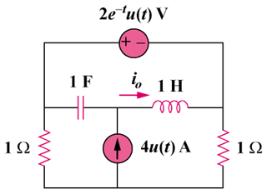

Figure 16.79
For Prob. 16.56.

Solution

We apply mesh analysis to the s-domain form of the circuit as shown below.

s

1

1

1/s

2/(s+1)
+

I₃

I₂

I₁

4/s

For mesh 3,
(1)

For the supermesh,
(2)

Adding (1) and (2) we get, I₁ + I₂ = –2/(s+1) (3)

But –I₁ + I₂ = 4/s (4)

Adding (3) and (4) we get, I₂ = (2/s) – 1/(s+1) (5)

Substituting (5) into (4) yields, I₁ = –(2/s) – (1/(s+1)) (6)

Substituting (5) and (6) into (1) we get,

Substituting (3) into (1) and (2) leads to

(4)

(5)

We can now solve for I_{o}.

I_{o} = I₂ – I₃ = (4/s) – (1/(s+1)) + ((–1.5+0.5j)/(s+j)) + ((–1.5–0.5)/(s–j))

or
i_{o}(t) = [4 – e^{–t} + 1.5811e^{–jt+161.57˚} + 1.5811e^{jt–161.57˚}]u(t)A

This is a challenging problem. I did check it with using a Thevenin equivalent circuit and got the same exact answer.

